ĐẠI HỌC BÁCH KHOA HÀ NỘI
TRƯỜNG CÔNG NGHỆ THÔNG TIN VÀ TRUYỀN THÔNG

BÁO CÁO BÀI TẬP
LẬP TRÌNH MẠNG

Trần Anh Minh - 20235382

HÀ NỘI, 06/2026

Ảnh khi chạy chương trình
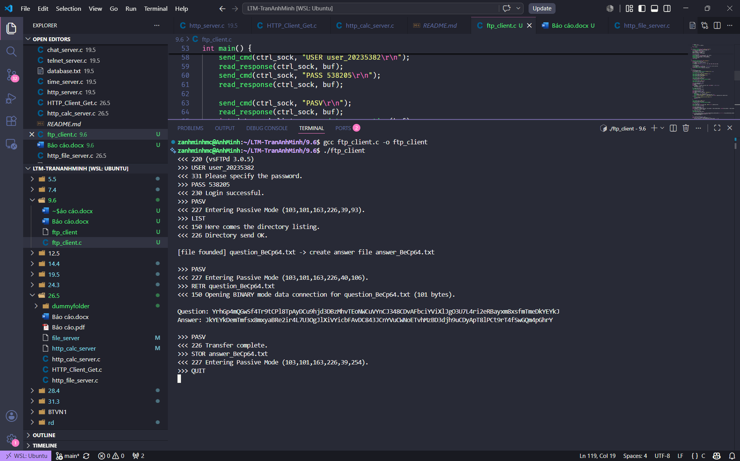
Source code
#define _GNU_SOURCE
#include <stdio.h>
#include <stdlib.h>
#include <string.h>
#include <sys/socket.h>
#include <arpa/inet.h>
#include <unistd.h>
#include <netdb.h>

#define BUFFER_SIZE 4096

void send_cmd(int sock, const char *cmd) {
send(sock, cmd, strlen(cmd), 0);
printf(">>> %s", cmd);
}

int read_response(int sock, char *buffer) {
memset(buffer, 0, BUFFER_SIZE);
int bytes = recv(sock, buffer, BUFFER_SIZE - 1, 0);
if (bytes > 0) {
printf("<<< %s", buffer);
}
return bytes;
}

int connect_to_server(const char *host, int port) {
int sock = socket(AF_INET, SOCK_STREAM, 0);
struct addrinfo hints, *res;
memset(&hints, 0, sizeof(hints));
hints.ai_family = AF_INET;
hints.ai_socktype = SOCK_STREAM;

char port_str[10];
snprintf(port_str, sizeof(port_str), "%d", port);
getaddrinfo(host, port_str, &hints, &res);
connect(sock, res->ai_addr, res->ai_addrlen);
freeaddrinfo(res);
return sock;
}

int open_data_connection(char *pasv_response) {
int h1, h2, h3, h4, p1, p2;
char *paren = strchr(pasv_response, '(');
if (!paren) return -1;
sscanf(paren, "(%d,%d,%d,%d,%d,%d)", &h1, &h2, &h3, &h4, &p1, &p2);

char data_ip[32];
snprintf(data_ip, sizeof(data_ip), "%d.%d.%d.%d", h1, h2, h3, h4);
int data_port = (p1 * 256) + p2;
return connect_to_server(data_ip, data_port);
}

int main() {
char buf[BUFFER_SIZE];
int ctrl_sock = connect_to_server("lebavui.io.vn", 21);
read_response(ctrl_sock, buf);

send_cmd(ctrl_sock, "USER user_20235382\r\n");
read_response(ctrl_sock, buf);
send_cmd(ctrl_sock, "PASS 538205\r\n");
read_response(ctrl_sock, buf);

send_cmd(ctrl_sock, "PASV\r\n");
read_response(ctrl_sock, buf);
int data_sock_list = open_data_connection(buf);

send_cmd(ctrl_sock, "LIST\r\n");
read_response(ctrl_sock, buf);

char list_output[8192] = {0};
int total_list_bytes = 0;
int bytes;
while ((bytes = recv(data_sock_list, buf, sizeof(buf) - 1, 0)) > 0) {
buf[bytes] = '\0';
strcat(list_output, buf);
}
close(data_sock_list);
read_response(ctrl_sock, buf);

char question_file[256] = {0};
char answer_file[256] = {0};
char *q_ptr = strstr(list_output, "question_");
if (q_ptr) {
sscanf(q_ptr, "%s", question_file);
sprintf(answer_file, "answer_%s", question_file + 9);
printf("\n[file founded] %s -> create answer file %s\n\n", question_file, answer_file);
} else {
printf("\nError: Question file not found.\n");
close(ctrl_sock);
return 1;
}

send_cmd(ctrl_sock, "PASV\r\n");
read_response(ctrl_sock, buf);
int data_sock_retr = open_data_connection(buf);

char retr_cmd[512];
snprintf(retr_cmd, sizeof(retr_cmd), "RETR %s\r\n", question_file);
send_cmd(ctrl_sock, retr_cmd);

char file_content[1024] = {0};
int total_content_bytes = 0;
while ((bytes = recv(data_sock_retr, file_content + total_content_bytes, sizeof(file_content) - total_content_bytes - 1, 0)) > 0) {
total_content_bytes += bytes;
}
close(data_sock_retr);
read_response(ctrl_sock, buf);

while (total_content_bytes > 0 && (file_content[total_content_bytes-1] == '\n' || file_content[total_content_bytes-1] == '\r')) {
file_content[total_content_bytes-1] = '\0';
total_content_bytes--;
}

char reversed_content[1024] = {0};
for (int i = 0; i < total_content_bytes; i++) {
reversed_content[i] = file_content[total_content_bytes - 1 - i];
}
printf("\nQuestion: %s\n", file_content);
printf("Answer: %s\n\n", reversed_content);

send_cmd(ctrl_sock, "PASV\r\n");
read_response(ctrl_sock, buf);
int data_sock_stor = open_data_connection(buf);

char stor_cmd[512];
snprintf(stor_cmd, sizeof(stor_cmd), "STOR %s\r\n", answer_file);
send_cmd(ctrl_sock, stor_cmd);

send(data_sock_stor, reversed_content, total_content_bytes, 0);
close(data_sock_stor);

read_response(ctrl_sock, buf);

send_cmd(ctrl_sock, "QUIT\r\n");
read_response(ctrl_sock, buf);

close(ctrl_sock);
return 0;
}

